Guidelines of 2-page Short Paper for the 6th BAJC Conference 2018

Tom Chena*, Ping Huangª, and Dominic C.Y. Foo^{b}

ª School of Chemical Engineering
^{b} School of Mechanical Engineering
The University of Queensland, St Lucia, QLD 4072, Queensland

*Corresponding Author’s E-mail: t.chen@uq.edu.au

Abstract This article serves as the template of the two-page short papers submitted to BAJC Conference 2018 - the 6th Conference of the Baosteel-Australia Joint Research and Development Centre (BAJC). The paper should highlight the key findings of the research associated BAJC projects and will be sent for review through the Technical Advisory Panel (TAP). The accepted short papers should be presented in the conference and will be published in the Book of Abstracts (short papers) in black and white. Please use this template when preparing your short paper. This will ensure a uniform format in the publication.

1. Introduction
The Short Paper should include a header as shown in this example, Title, <single 11pt line space> Authors, <single line space>, Affiliations, <single line space>, the E-mail address of Corresponding Author, <double line space>, Abstract, additional information in the form of Tables, Figures, Equations, Acknowledgement, and References.

2. Methodology
The required font size is 12pts for the paper title, 9pts for References and Table contents, and 11pts elsewhere. Use a Times New Roman font with single spacing between lines. The main text should be justified on both sides. Use a blank line between paragraphs and two blank lines between Abstract. Do not use footnotes. The length of the abstract should not exceed 10 lines (about 200 words). Other specific guidelines for each section are given below.

- Title: Please provide a descriptive title of the paper. The title should be concise and not span more than 2 lines. Use Times New Roman font with a font size of 14pts and in boldface for the title. The title should be centred.

- Authors and Affiliations: Include the first name, middle initial and surnames of all the authors. Use Times New Roman font with a font size of 11pts for the Authors and Affiliations. The name of the corresponding author should be underlined. The affiliations of all the authors should be included on separate lines. The e-mail address of the corresponding author should be shown. The author, affiliations, and email address should be centred.

- Abstract: Use Times New Roman font with a font size of 11pts for the abstract. The Abstract and main text should be justified on both sides.

- Tables: Tables should be numbered and captioned. Use Times New Roman font with a font size of 9pts for the table’s contents. As a guideline, the short paper should not contain more than 2 Tables. Place the Table caption above the Table and centred. The Following is an example for a Table.

Table 1: Important dates for BAJC Annual Conference 2018.
Date | Activity
November 15, 2017 | Open for Abstract and Registration
January 15, 2018 | Deadline of Abstract submission
January 15, 2018 | Free Early-Bird Registration (conditions apply*)
January 19, 2018 | Registration Deadline ($200 Registration fee applied)
January 25, 2018 | Submission of PPT Presentation (expected)
January 29, 2018 | Conference
*Registered delegates making use of the BAJC sponsored early bird registration must attend or send
substitutes, or will be billed a normal registration of $200 (as cost recovery for BAJC on meals, venue etc).
- Figures: The figures should be numbered and captioned and provided in at least 300 dpi resolution. As a guideline, the abstract should not contain more than 2 figures. The Figure caption should be below the Figure and centred. Use a line or 1/2 single line (6pts) space to separate the figure caption from the preceding paragraph, the figure from the caption, and the figure body and next paragraph.
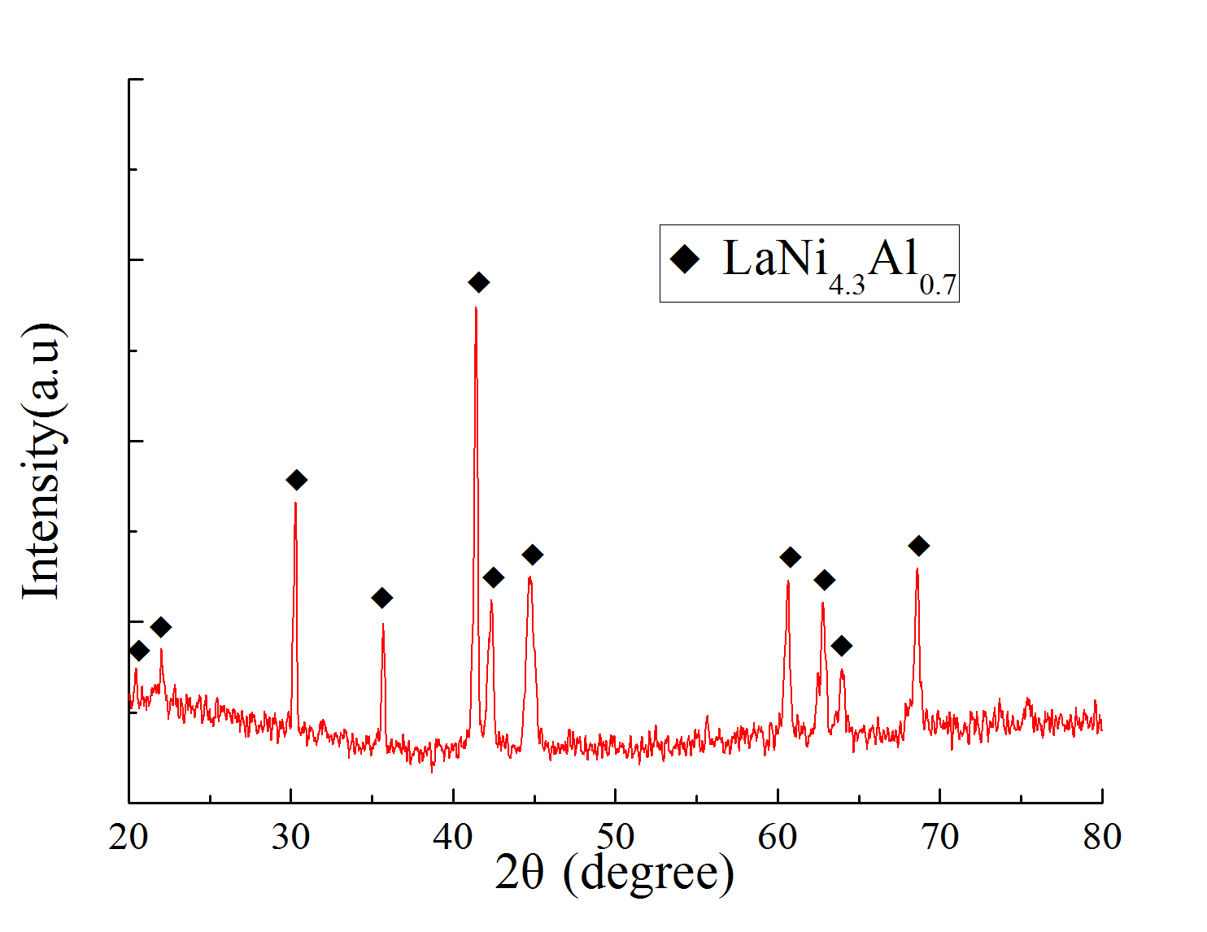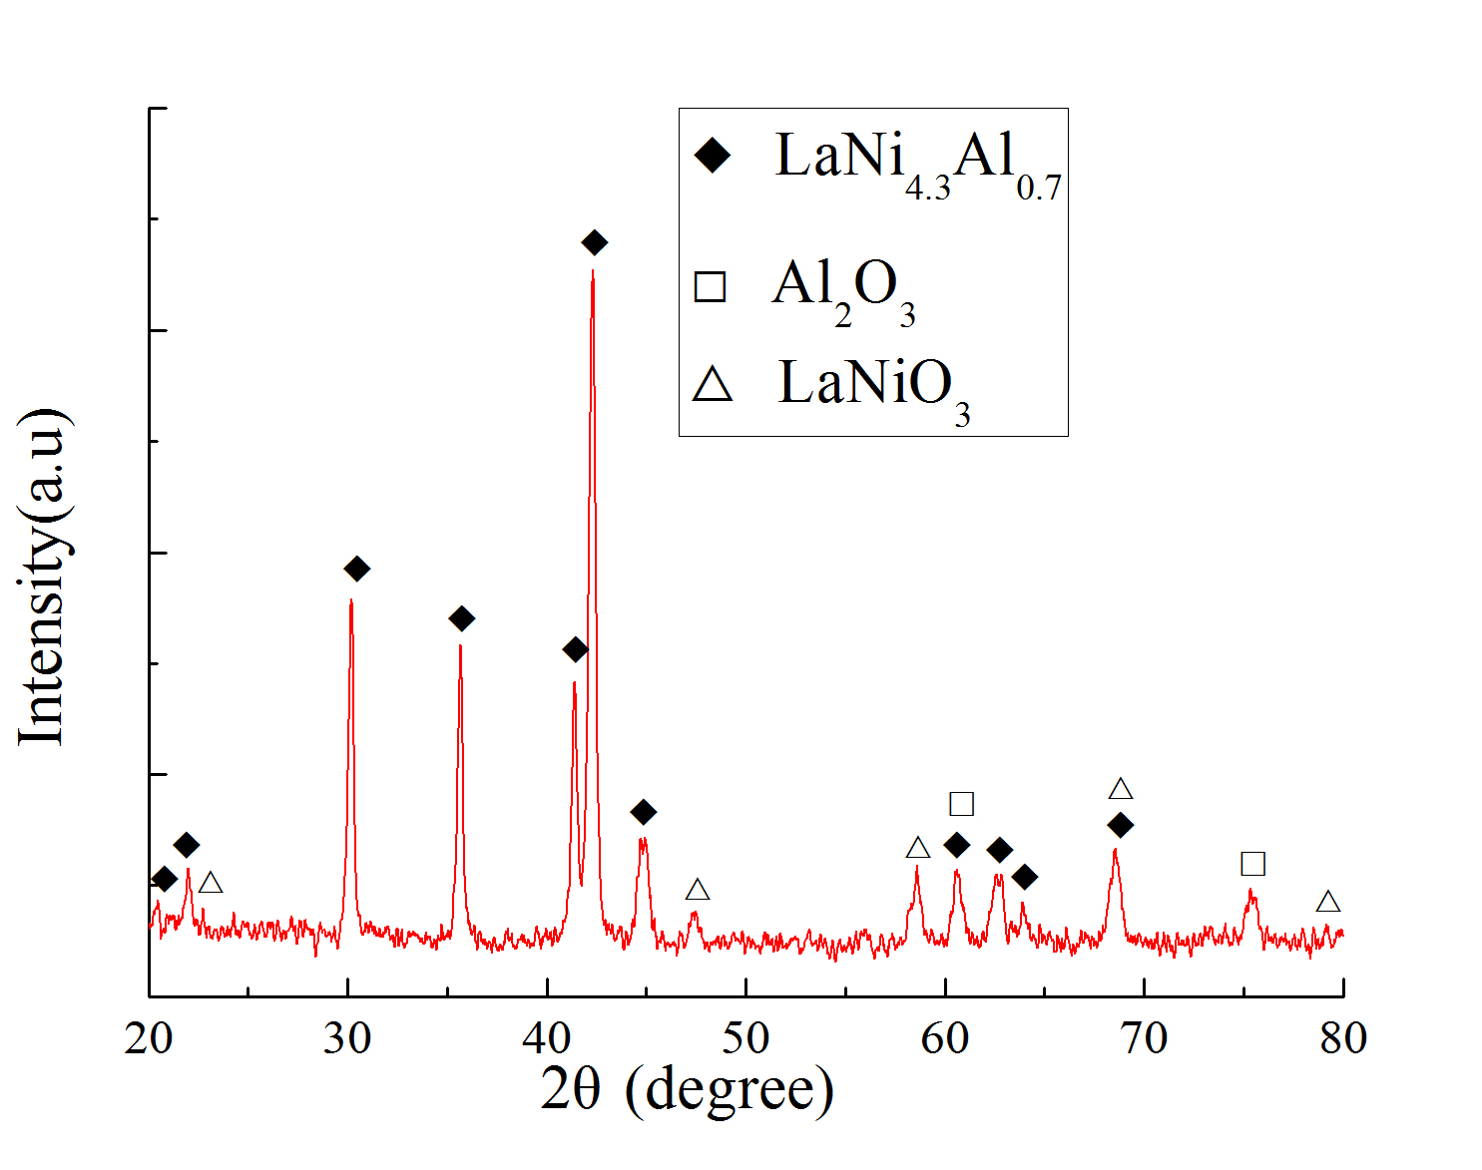
(a) Unreacted sample (b) Activated sample

Figure 1. XRD patterns of the samples before and after reaction with pure hydrogen.
- Equations: The equations should be indented with the numbers displayed on the right side in parenthesis.
$E={mc}^{2}$ (1)

3. Results and Discussion
Use the Times New Roman font with a font size of 9pts for the References. In the text, refer to literature citations in the author-year format, e.g. [Author, 2006] or [Author 1 and Author 2, 2016] or [Author 1 et al., 2017]. The references should be placed at the end of the extended abstract in alphabetical order.

4. Conclusions
Acknowledgements can be included at the end of the main body but before the references. BAJC R&D Fund should be acknowledged listing the corresponding BAJC project number.

Acknowledgements
This research forms part of the Baosteel Australia Research and Development Centre (BAJC) portfolio of projects and has received support through the Centre, project BAJC 160xx.

References
- Aguilar O., Perry S. J., Kim J.-K. and Smith R. Design and Optimization of Flexible Utility Systems Subject to Variable Conditions, Part 2: Methodology and Applications, Chem Eng Res Des, 85, 1149-1168, 2007.
- Bruno J. C., Fernandez F., Castells F. and Grossmann I. E. A Rigorous MINLP Model for The Optimal Synthesis and Operation of Utility Plants, Chem Eng Res Des, 76, 246-258, 1998.
- Hui C. W. and Natori Y. An Industrial Application Using mixed-integer Programming Technique: A Multi-period Utility System Model, Comput Chem Eng, 20, S1577-S1582, 1996.

