Template of Two-page Short Paper for the 8th BAJC Conference 2026

Tom Chen*, Ping Huangª, and Dominic Foo^{b}

ª School of Chemical Engineering
^{b} School of Mechanical Engineering
The University of Queensland, St Lucia, QLD 4072, Queensland

*Corresponding Author’s E-mail: t.chen@uq.edu.au

Abstract This article serves as the template of the two-page short papers submitted to BAJC Conference 2026 - the Conference of the Baosteel-Australia Joint Research and Development Centre (BAJC). The paper should highlight the key points or findings of the research that may or may not associated BAJC projects. All submitted papers will be reviewed through the Technical Advisory Panel (TAP). Accepted papers must be presented at the conference and will be included in the 2026 BAJC Conference Abstract Book published by BAJC. Please use this template when preparing your paper to ensure uniform formatting across all submissions.

1. Introduction
The Paper should include a header as shown in this example, Title, <single 11pt line space> Authors, <single line space>, Affiliations, <single line space>, the E-mail address of Corresponding Author, <double line space>, Abstract, additional information in the form of Tables, Figures, Equations, Acknowledgement, and References.

2. Methodology
The required font size is 12 pt for the paper title, 9 pt for References and Table contents, and 11 pt for all other text. Use Times New Roman font with single line spacing. The main text should be fully justified. Insert one blank line between paragraphs and two blank lines between the Abstract and the main text. Do not use footnotes. The Abstract should not exceed 10 lines (approximately 200 words). Other specific guidelines for each section are outlined below.

- Title: Provide a descriptive and concise title that does not exceed two lines. Use Times New Roman 14 pt, boldface, centred.

- Authors and Affiliations: List first name, middle initial (if any), and surnames of all authors. Use Times New Roman 11 pt. Underline the name of the corresponding author. Provide affiliations on separate lines. Centre the author names, affiliations, and corresponding author email address.

- Abstract: Use Times New Roman 11 pt. Align text to both left and right margins.

- Tables: Tables must be numbered and captioned. Use Times New Roman 9 pt for table contents. Limit to a maximum of two tables. Place the Table caption above the table and centre it. The Following is an example for a Table.

Table 1: Important dates for BAJC Conference 2026.
Date | Activity
December 2, 2025 | Call for Abstract Opens
February 20, 2026 | Early-Bird Registration Close
February 16, 2026 | Abstract Submission Close
March 2-3, 2026 | Conference Date

- Figures: Figures should be numbered and captioned, with a minimum resolution of 300 dpi. Limit to a maximum of two figures. Place captions below figures and centre them. Use a 6-pt (half-line) space above the caption, between the figure and caption, and between the figure and the following paragraph.
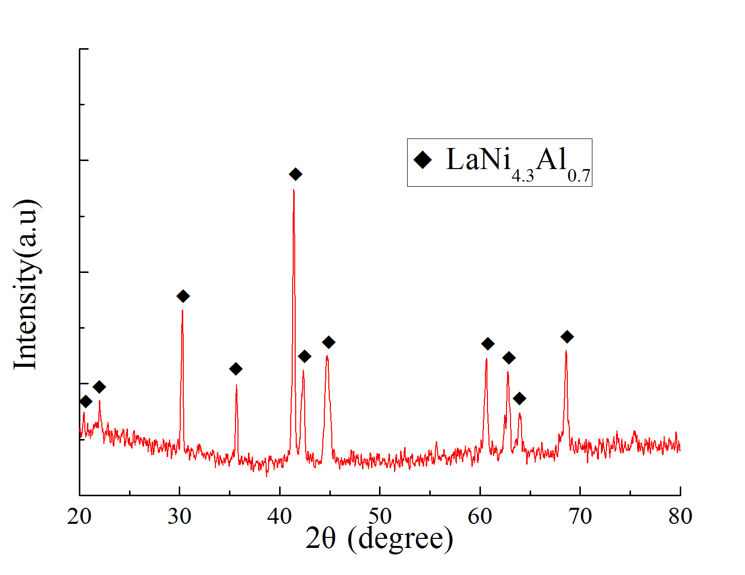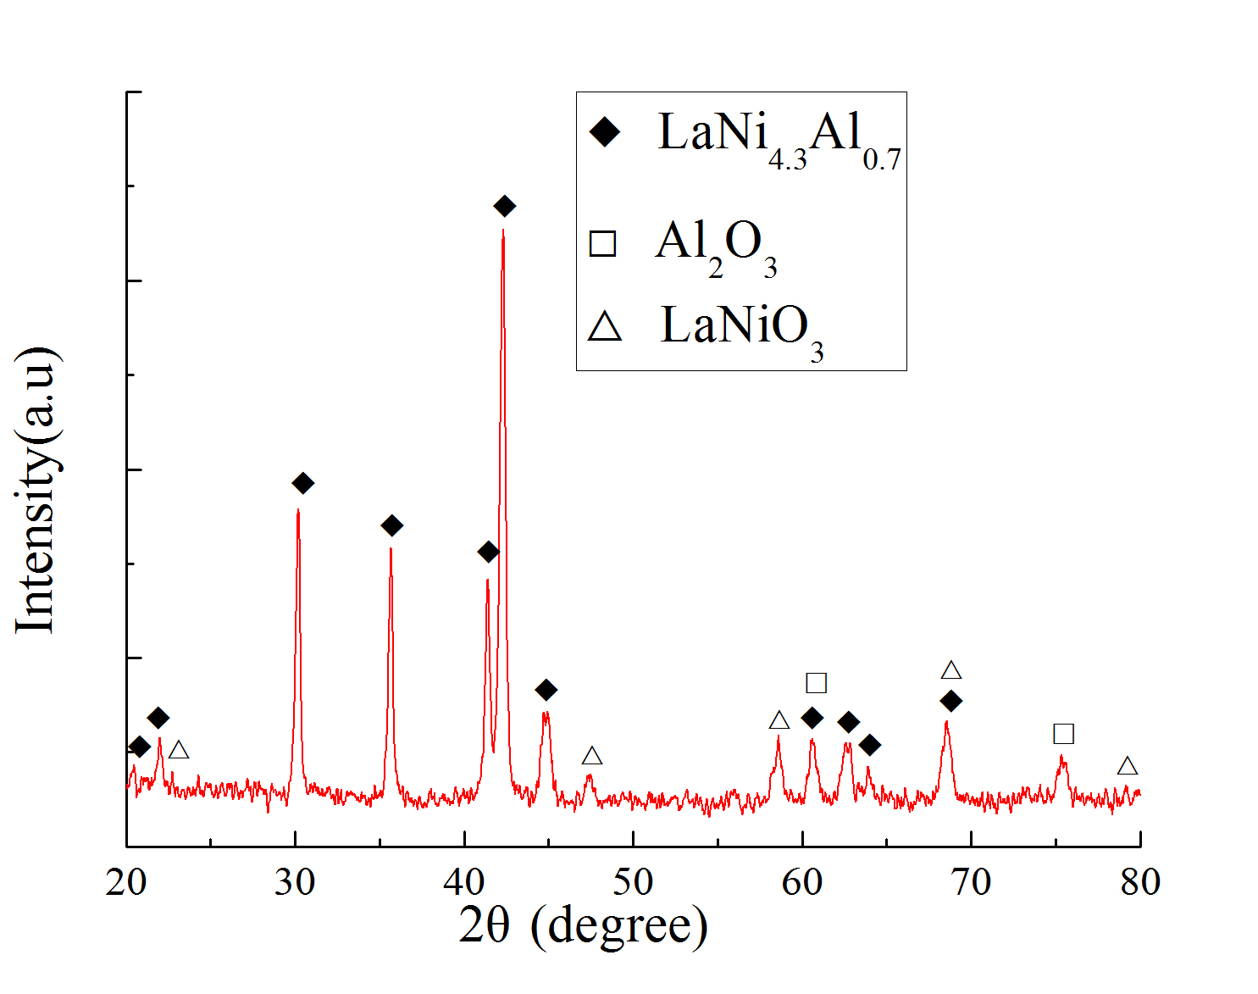
(a) Unreacted sample (b) Activated sample

Figure 1. XRD patterns of the samples before and after reaction with pure hydrogen.
- Equations: Indent equations and place equation numbers in parentheses on the right.

$E={mc}^{2}$ (1)

3. Results and Discussion
Use Times New Roman 9 pt for the References section. In the text, cite literature in author-year format, e.g. [Author, 2006], [Author 1 and Author 2, 2016], or [Author 1 et al., 2017]. List all references at the end of the paper in alphabetical order.

4. Conclusions
Acknowledgements should appear at the end of the main text but before the References. The BAJC R&D Fund must be acknowledged, including the relevant BAJC project number.

Acknowledgements
This research forms part of the Baosteel Australia Research and Development Centre (BAJC) portfolio of projects and has received support through the Centre, project BAJC.

References
- Aguilar O., Perry S. J., Kim J.-K. and Smith R. Design and Optimization of Flexible Utility Systems Subject to Variable Conditions, Part 2: Methodology and Applications, Chem Eng Res Des, 85, 1149-1168, 2007.
- Bruno J. C., Fernandez F., Castells F. and Grossmann I. E. A Rigorous MINLP Model for The Optimal Synthesis and Operation of Utility Plants, Chem Eng Res Des, 76, 246-258, 1998.
- Hui C. W. and Natori Y. An Industrial Application Using mixed-integer Programming Technique: A Multi-period Utility System Model, Comput Chem Eng, 20, S1577-S1582, 1996.

